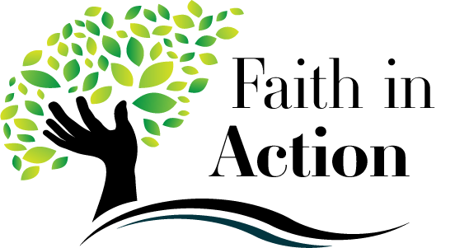
Activity #10 – Grades 1-4
Bring this completed paper to class with you on Sunday, March 3 or Wednesday, March 6, 2024.

Name ________________________________
Our Lenten Journey Continues

Each day in Lent is an opportunity for us to be a better person. We become more aware of God’s love for us. We also become more aware that Jesus told us to love our neighbors as we love ourselves.

- With someone from your family, listen again to a Lenten hymn below or another Lenten hymn.

“Hosea” https://www.youtube.com/watch?v=FB0TWvag_Ic&ab_channel=maryelizabethanne2 or google youtube hosea first penance talbot.

“Transfigure Us, O Lord” at https://www.youtube.com/watch?v=Gr_sywDAn-c or google youtube st bridget school transfigure us O Lord.

What did you like about listening to the hymn? ______________________________________

- What do you like about your prayer place? Or, do you want to change your prayer place so it is a better reminder of God’s love?

______________________________________________________________________________

______________________________________________________________________________

- What is one thing that your family is doing during Lent? Ask someone in your family to help you with this question. Who in your family did you talk to about this question?

_____________________________________________________________________________

_____________________________________________________________________________

- What is one thing you are doing this Lent so far to help someone carry their cross?

________________________________________________________________________

- Draw a picture of yourself helping another person. This is a way that you help them carry their cross.

