Activity #11 – Grades 7-8
Bring this completed paper to class with you on Sunday, March 17 or Wednesday, March 20, 2024.

Name ________________________________
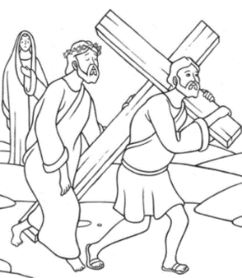
Carrying the Cross

Part 1: In the story of Jesus’ passion, Simon of Cyrene does something for Jesus. Read Matthew 27:32
What did Simon do? ___________________________________________
How do you think Simon felt about doing this? Why? _______________________

___________________________________________________________________________________

Look up a definition of fortitude and write it here._____________________________________________

___________________________________________________________________________________

Think of a situation in your life where you would like to have the gift of fortitude. Write just one word to

remind you of that situation. _____________________________________________________

During Lent, think of a way you can help someone carry their cross. You can be good to someone who is not feeling well or has had a hard day. You can stand up for someone who is being bullied or faces discrimination. Ask your family for an idea of what you can do to help another person. We help each other to carry our cross, as Simon of Cyrene helped Jesus by carrying his cross.

What did you decide to do to help another person carry her/his cross? __________________________

__________________________________________________________________________________

Whom did you talk to for help getting an idea? _____________________________________________

Part 2: You have received a small, simple stone with a cross. The cross reminds us of Jesus’ love for us and the love we need to have for each other.

Use this cross and make a prayer place. A prayer place is anywhere that is meaningful to you. You can put the cross on your dresser or desk, keep it somewhere you will look at often, or keep it in your pocket so you can touch it during the day. Ask someone in your family to help you decide on a good prayer place. When you go to your prayer place or see the cross each day, say a short prayer. Thank God for something. Or, you can ask God for help with something that is important to you.

Where is your prayer place?____________________________________________________________

Why did you choose that as your prayer place? Why is that good for you? How will that help you?

__________________________________________________________________________________

__________________________________________________________________________________

