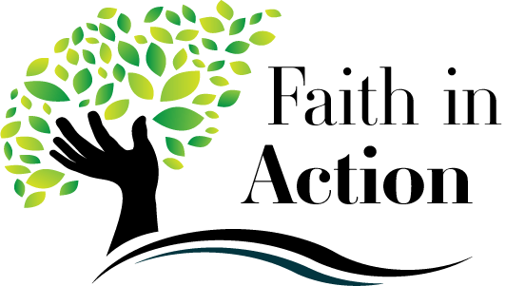
Activity #10 Name ________________________________
Bring your completed activity to class on Sun March 3 or Wed March 6

PART 1: What Would Jesus Do? Beatitudes as a Path to True Happiness

The Beatitudes are the teachings of Jesus in the Sermon on the Mount (Matthew 5:1-10)
These are Jesus’ guidelines to live a happy life.

1. Blessed are the poor in Spirit, for theirs is the kingdom of Heaven.
(Being humble and noticing your strengths as well as weaknesses & you will be respected for who you are)
2. Blessed are they who mourn, for they shall be comforted.
(Experience God’s comfort in our pain…joining in the sorrow of anyone who is suffering)
3. Blessed are the meek, for they shall inherit the earth.
(Being gentle…treating others with kindness…being selfless…serving others with joy)
4. Blessed are they who hunger and thirst for righteousness, for they will be satisfied.
(Fighting for justice…leading others to do good...upholding your morals and ethics)
5. Blessed are the merciful, for they will be shown mercy.
(Forgiving others…reaching out to the suffering and poor with mercy...be compassionate)
6. Blessed are the pure of heart, for they will see God.
(Being holy and chaste, doing God's will in everything, focus on goodness in thoughts, intentions & desires)
7. Blessed are the peacemakers, for they will be called children of God.
(Being at peace with yourself, others & God…prevent arguments, settle disputes, tolerate, try not to judge)
8. Blessed are those who are persecuted for the sake of righteousness, for their reward will be great in heaven.
(Taking a stand for truth and justice even when being attacked by others...follow Jesus no matter what)

Which Beatitude do I need to work on the most and why? 3 or more sentences

If you can add one more of your own Beatitude for teens, what would it be? Write it below.

Log on your Ascension Press online access. Go to Lesson 20 and watch segment 2 .video presentation 20.2 Franciscan Friars of Renewal 420 E 156th street NYC. In what ways would you say the friars are living out the Beatitudes? How do you think the people in the community view them?
______________________________________________________________________

______________________________________________________________________

______________________________________________________________________

______________________________________________________________________

______________________________________________________________________

______________________________________________________________________

______________________________________________________________________
PART 2: Living the Beatitudes is made possible by the Holy Spirit. With a family member fill out this chart.
Which Beatitude Am I? | Seeking
 | I want to be in total control of my life, my desires and the people around me…I love all my stuff, I must have my cell phone with me all the time… Lord, help me! I belong more to this world than to heaven….
 | I want everyone to like me and approve of me…so I won’t stick up for what is right even though I know what's right in my heart…I’d rather follow my friends on social media than Jesus, even though my conscience knows what's right… Help me Lord!
 | I'm quicker to complain about people more than I am to give them mercy…I remain frustrated because people don't change the way I want them too, so why show compassion? Help me Lord!
 | I don't care if anyone else is suffering, hungry, poor, depressed or homeless…why should I mourn for them? …it doesn't affect me…Oh Lord, help me!
 | I'm more interested in picking fights than making peace…I'm not going to get involved in anyone else's argument that has nothing to do with me even if I can help settle it…Lord, help me!
 | I hunger and thirst for making myself feel good like watching a lot of TV, avoiding work and following the wrong crowd than doing what’s right and spending time in prayer. Lord, help me, please!
 | I'm not going to be kind all the time…it's a waste of energy…others aren't always nice to me…Hey, I'm only concerned about myself…I have to look out for #1 me! Lord, help me serve others!
 | I’m perfect. I don’t need to go to church. I’m not really a sinner. I don’t need to admit to anything. Why should I waste my time reading the bible!? I know how to live on my own. Help me Lord!

